Fun Fair

Big Games:

Shoot the cannons (alien pistol against alien cannons [moving])

Alien Bowling (with exploding balls)

Something with the Robot

Something with magic wand (shoot and levitate [sockets?])

Small games:

Bow and Arrow

Bouldering

Throw something at something

Besides:

Animals to pet

* Walls that can be bombed when finishing a big game
* Keys to open doors when finishing a small game

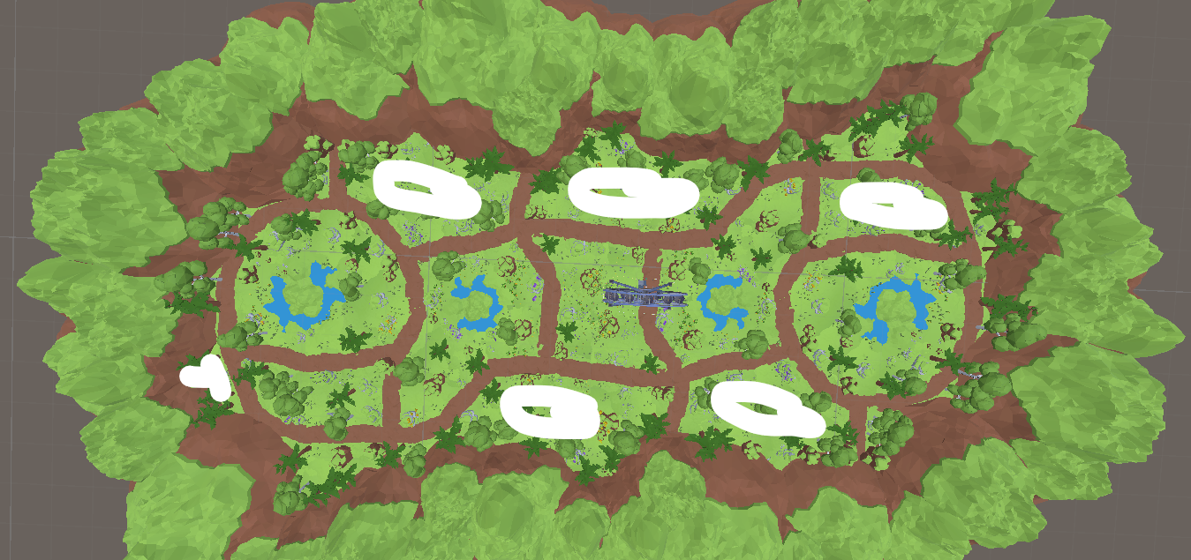

Alien Names:

Cabbage

Beany

Squash

Peas

Cucumb

Radish

Brocco

Corny

Sprouts